Kanaan Christabel 11/12/19

**Week9**

**Q :1**

Use a weather forecast website, and utilize the psychometric chart and the formula we went through in the class to determine the absolute humidity, the wet-bulb temperature and the mass of water vapor in the air in Classroom A (Aula A) of Piacenza campus in the moment that you are solving

Umidità: Relative humidity, Pressione atmospheric: Air total pressure (1 hPa: 0.1 kPa), Temperature effettiva: temperature to be utilized.

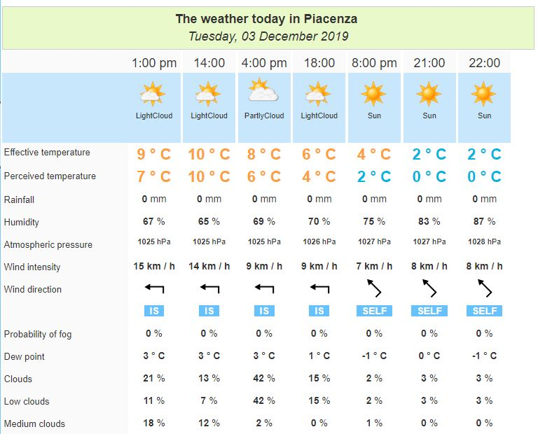

The hour at the moment is 14:30. According to the weather forecast shown above we know that there is no chances of rainfall, effective temperature 9˚C (T= 282.15 Kalvin), the humidity is 65% (relative humidity Φ= 65%), and the atmospheric pressure 1025 hPa (total air pressure P= 102.5 kPa)

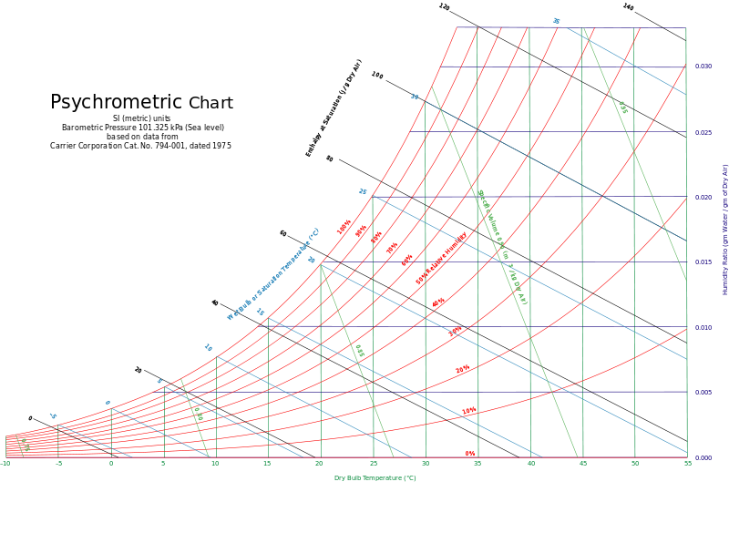

Utilize the psychometric chart, we can see, the humidity ratio, i.e., the absolute humidity ω=0.0052

The web-bulb temperature Twb = 10˚C

Therefore ω= $\frac{0.622 Pv}{Pa}=\frac{0.622 Pv}{P-Pv}$ = 0.0052, introduce P = 102.5 KPa into this equation, and solve it. $\frac{0.622 Pv}{102.5-pv}=0.0052$

PV = 0.8498 KPa

Autem, Φ= $\frac{mv}{mg}$ = 70% ……. (1)

For any ideal gas, m = $\frac{Pv}{RSPT}$, during the class we were told that for water vapor, Rsp= 0.4615

Introduce the pressure of water vapor PV = 0.8498 KPa, and define the volume of Aula A is

V: mv = = 130.212225 V

Subordinate this value to equation number (1)

Calculate the maximum water vapor mg = = 9.34 x 10 -3V

**Question 2**

[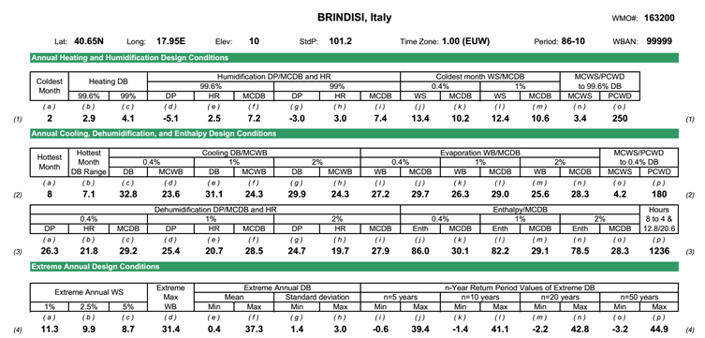](https://github.com/bnajafi/TES_2019-2020_weeklySubmissions/blob/master/Week%209/image.png)Utilize the same methodology we went through in the class and determine the sensible and latent load corresponding to internal gains, the ventilation, and the infiltration in a house with a *good* construction quality and with the same geometry as that of the example which is located in Brindisi, Italy

Height= 2.5 m; Floor area= 200 m2; Wall area= 144 m2

Internal Gains:  
Sensible cooling load from internal gains,  
qig,sensible = 136+2.2Acf+22Noc= 136+2.2*200+22*2 = 620W

Latent cooling load from internal gains,

qig,latent = 20+0.22Acf+12Noc= 20+0.22*200+12*2 = 88W

Infiltration:  
Unit leakage area Aul= 1.4 cm2/m2  
Exposed surface AL= A(wall)+ A(roof)= 200+144= 344m2

So, AL= Aes*Aul= 344*1.4= 481.6 cm2

Define the cooling temperature Tcooling = 24°C, and heating temperature Theating = 20°C in Brindisi,

∆ T cooling = 31.1– 24 = 7.1°C = 7.1 k

∆ T heating = 20 °C – (- 4.1°C) = 24.1 °C = 24.1 k

DR = 7.1 °C = 7.1 k

Given: IDF (heating) = 0.073 $\frac{L}{s*cm2}$

IDF (cooling) = 0.033 $\frac{L}{s*cm2}$

Calculate infiltration airflow rate,

Q I, heating = AL * IDF heating = 481.6 * 0.073 = 35.157 $\frac{L}{s}$

Qi,cooling = AL * IDF cooling = 481.6 * 0.033 = 15.893 $\frac{L}{s}$

The required minimum whole building ventilation rate is

Qv= 0.05Acf + 3.5 ( Nbr + 1) = 0.05 * 200 + 3.5 * (1+1) = 17 $\frac{L}{s}$

Thus,

Qi-v, heating = Q I, heating + Qv = 35.157 + 17 = 52.157 $\frac{L}{s}$

Qi-v, cooling = Q I, cooling + Qv = 15.893 + 17 = 32.893 $\frac{L}{s}$

Given that Csensible = 1.23, Ctalent = 3010, ∆w cooling = 0.0039

$\dot{q}$ inf-ventilation ( cooling sensible) = C sensible Q i-v,cooling ∆Tcooling = 1.23 * 32.893 * 7.1 = 287.25 W

$\dot{q}$ inf-ventilation ( cooling talent) = C talent Q i-v,cooling ∆wcooling = 3010 * 32.893 * 0.0039 = 386.13 W

$\dot{q}$ inf-ventilation ( heating sensible) = C sensible Q i-v,cooling ∆Theating = 1.23 * 52.157 * 24.1 = 1546.09W